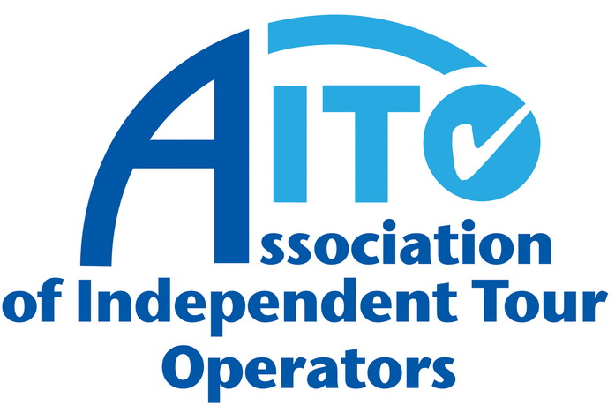
AITO announces 2013 Travel Writer of the Year awards

AITO yesterday announced the results of its 17th Travel Writer of the Year awards. This year saw the highest number of entries ever, with just over 200 articles submitted. A new category was introduced for the first time this year – AITO Travel Blogger of the Year, with the two other award categories being Travel Writer of the Year and Young Travel Writer of the Year. These awards were presented at AITO Meets the Media, held at the Millennium Gloucester Hotel on 19 November.

AITO Travel Writer of the Year
The winner of the AITO Travel Writer of the Year 2013 award is Mark Jones, with his BA High Life article entitled ‘A Galapagos Miscellany,’ documenting his trip to the extraordinary islands off the coast of Ecuador. The article was a clear winner this year, with the judges commending Mark for “interestingly conveying startlingly different views of Darwin and the islands so as to jar the reader’s mind into thinking more.” The judges said: “Mark’s informal and light-hearted style of writing keeps the reader completely engaged… it is thought-provoking and interesting, whilst maintaining a humorous touch.”

In second place is Peter Hughes writing for The Daily Telegraph with his article ‘Turkey by gulet: sailing in the company of the ancients’. Peter describes his sailing journey through the archaeological treasures of Turkey, demonstrating that gulet cruising isn’t just for the young and those who don’t mind roughing it. The judges could not fail to agree with Hughes that a mix of seductive Aegean islands and the promise of a little earnest archaeology was irresistible.

In joint-third place are Amanda Canning of Lonely Planet Traveller with her article ‘On Holiday with Miss Kim,’ about discovering North Korea’s land and the people behind the headlines, which the judges found to be “well reported and insightful” - and Michelle Jana Chan’s ‘Brave New Worlds’ piece for Condé Nast Traveller about the tropical island of Príncipe, which the judges said was “an inspirational read and offering real insight into entrepreneurs with a passion”.

AITO Young Travel Writer of the Year

This winner of this award, which celebrates new travel writing talent, is Alasdair Baverstock of The Daily Telegraph for his article ‘Venezuela: piranha fishing in the Orinoco Delta’ where he explores the busy network of canals flowing through this region. One of the judges commented that “you can feel the rum go down and the mosquitoes come out,” whilst another said “it brought back memories and made me think back to my own stunning trips down the Orinoco”.

AITO Travel Blogger of the Year
This category is new for this year and was introduced to recognise the increasing influence of talented travel bloggers. The winner of AITO’s Travel Blogger of the Year award is Charlie Walker of Charlie Walker Explores for his articles about travelling around Iran on a bike. The judges said the article was “an absolutely riveting read and a highly absorbing account of life in Iran, as experienced by a man on a bike” and “conveyed a definite sense of place, which included fascinating and very rich anecdotes.”

The Chairman of AITO, Derek Moore, says: “Huge congratulations to all of the entrants for such a high standard this year. We saw a record number of entries - just over 200 - with the new category, ‘AITO Travel Blogger of the Year,’ proving pleasingly popular. Many of these entries were extremely well written, ensuring the judges had a mammoth task in trying to pick the winners.

“It shows just how many truly skilled travel writers there are across a huge array of print and online publications in the UK. These awards specifically aim to reward writers whose copy is inspirational, informative and interesting. Our 2013 winners crafted inspirational travel tales that informed the reader of a multitude of fascinating facts – inspiring them to pack their bags or to dream of doing so.”

AITO welcomes one entry per person for its Travel Writer of the Year Awards, and encourages travel editors to enter pieces that have been published on their pages or their sites during the course of the calendar year.

For further information, visit www.aito.com.

Ends 20 November 2013

Press: For further information on AITO, please contact Travel PR on 020 8891 4440 or email Stephanie Reed (s.reed@travelpr.co.uk) Rebecca Milne (r.milne@travelpr.co.uk) or Sue Ockwell (s.ockwell@travelpr.co.uk).

Notes to editors:
Shortlisted from a total of over 200 entries, the names of those who scored highest are as follows:

The top five places for the AITO Travel Writer of the Year award 2013

- Mark Jones
- Peter Hughes
- Amanda Canning and Michelle Jana Chan (joint third place)
- Stanley Stewart and Amar Grover (joint fourth place)
- Nigel Tisdall

The top five places for the AITO Young Travel Writer of the Year award 2013

- Alasdair Baverstock
- Hanna Lindon
- Katie McGonagle
- Lucy Purdy
- Jane Duru

The top five places for the AITO Travel Blogger of the Year award 2013

- Charlie Walker
- Sarah Warwick
- Justin Marozzi
- Lizzie Porter
- Susan T Kime

Thank you to everyone who entered the AITO Travel Writer of the Year awards.

Press: For further information on AITO, please contact Travel PR on 020 8891 4440 or email Stephanie Reed (s.reed@travelpr.co.uk) or Sue Ockwell (s.ockwell@travelpr.co.uk).

The AITO Travel Writer of the Year award
Celebrating 17 years of excellence in travel writing

1997 Jill Crawshaw (The Times and The Independent on Sunday)

1998 David Wickers (The Sunday Times)

1999 Jane Bussman (The Mail on Sunday)

2000 Max Anderson (The Sunday Times)

2001 Matt Rudd and Stephen Bleach (joint winners – The Sunday Times)

2002 William Gray (Wanderlust)

2003 Peter Hughes (The Daily Telegraph)

2004 Brian Jackman (The Daily Telegraph)

2005 Nigel Tisdall (Ultratravel Magazine, The Daily Telegraph)

2006 Chris Haslam (The Sunday Times)

2007 Peter Hughes (The Daily Telegraph)

2008 Chris Haslam (The Sunday Times)

2009 Minty Clinch (FT/How to Spend It magazine)

2010 Stephen Bleach (The Sunday Times)
2011 Stephen Bleach (The Sunday Times)

2012 Oliver Smith (Lonely Planet Traveller)

2013 Mark Jones (BA High Life)

AITO Young Travel Writer of the Year award

2010 Oliver Smith (Lonely Planet magazine)

2011 Nick Boulos (Wanderlust)

2012 Rory Goulding (Lonely Planet Traveller)

2013 Alasdair Baverstock (The Daily Telegraph)

Ends 20 November 2013

Press: For further information on AITO, please contact Travel PR on 020 8891 4440 or email Stephanie Reed (s.reed@travelpr.co.uk), Rebecca Milne (r.milne@travelpr.co.uk)
or Sue Ockwell (s.ockwell@travelpr.co.uk).

